THEORIC CONTENTS

* Lesson 2. Algorithms.
* Lesson 3. Data Types.
* Lesson 4. Operators and Expressions.
* Lesson 5. Input and Output
* Lesson 6. Flow Control: Selection
* Lesson 7. Flow Control: Repetition

GITHUB CLASSROOM ASSIGNMENT

https://classroom.github.com/a/FWfR7f93

PROPOSED EXERCISES

Exercise 1. Design and implement a program in C that computes the ex-according to the Tailor series:



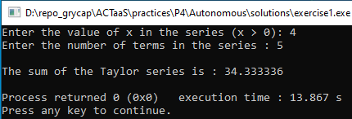

Exercise 2. Design and implement a program in C that displays a sequence of integers from an initial value to a final value. The initial and final values must be given by the user. For each integer, in a new line, the program should display the value corresponding to its square and its cube.

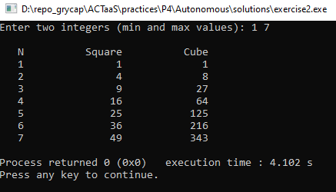

Exercise 3. Design and implement a program in C that displays a sequence of even integers from an initial value to a final value. The initial and final values must be given by the user. For each integer, in a new line, the program should display the value corresponding to its square and its cube.

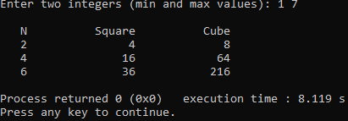

Exercise 4. Design and implement a program in C to convert Celsius degrees to Fahrenheit. The program should request the starting Celsius value, the ending Celsius value, and the increment. The display should have appropriate headings and list the Celsius value and the corresponding Fahrenheit value. Use the relationship: Fahrenheit = (9.0/5.0)*Celsius + 32.0.

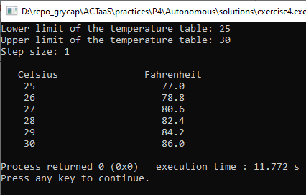

Exercise 5. Design and implement a program in C to reverse the digits of a positive integer number. For example, if the number 8735 is entered, the number displayed should be 5378.

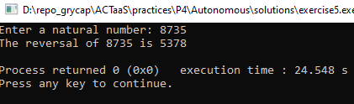

Exercise 6 .A bookstore summarizes its monthly transactions by keeping the following information for each book in stock:

Book identification number

Inventory balance at the beginning of the month

Number of copies received during the month

Number of copies sold during the month

Design and implement a program in C that accepts this data for each book and then displays the book identification number and an updated book inventory balance. The program should end when the user enters a negative book identification number.

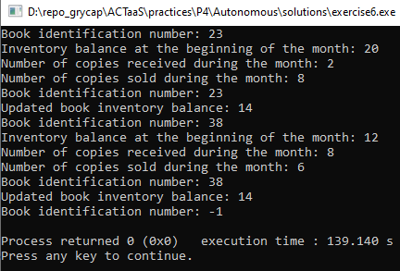

Exercise 7. Design and implement a program in C that print the decimal values of all characters between the start and stop characters entered by a user. For example, if the user enters an a and z, the program should print all the characters between a and z and their respective numerical values. Make sure that the second character entered by the user occurs later in the alphabet than the first character. If it does not a new value for the second character must be read, until the condition is satisfied.

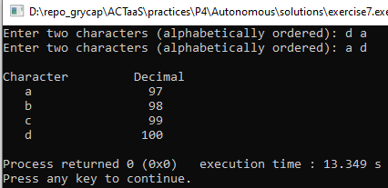

Exercise 8. Design and implement a program in C in which a machine purchased for $28,000 is depreciated at a rate of $4,000 a year for seven years. Write a C program that computes and displays a depreciation table for seven years. The table should have the form:

DEPRECIATION SCHEDULE

------------------------------------

END-OF-YEAR ACCUMULATED

YEAR DEPRECIATION VALUE DEPRECIATION

-------------------------------------------------------------------------------------

1 4000 24000 4000

2 4000 20000 8000

.

.

7 4000 0 28000

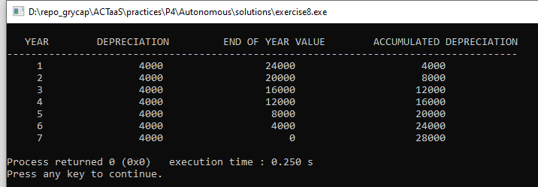

The output of this program must be aligned, according to the previous example. The alignment should be obtained using the printf modifiers.

Exercise 9. A well-regarded manufacturer of widgets has been losing 4 percent of its sales each year. The annual profit for the firm is 10 percent of sales. This year the firm has had $10 million in sales and a profit of $1 million. Determine the expected sales and profit for the next 10 years. Your program should complete and produce display as follows:

SALES AND PROFIT PROJECTION

----------------------------------------------------------------------

YEAR EXPECTED SALES PROJECTED PROFIT

----------------------------------------------------------------------

1 $10000000 $1000000

2 $ 9600000 $ 960000

3

.

.

10

----------------------------------------------------------------------

Totals: $ $

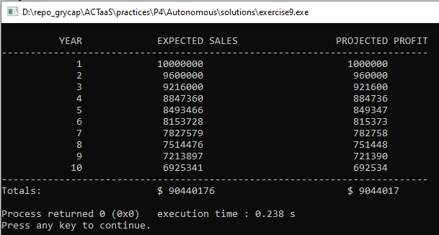

Exercise 10. Design and implement a program in C that Write a C program that calculates and displays the yearly amount available if $1,000 is invested in a bank account for 10 years, considering different interest rates: from 6% to 12%

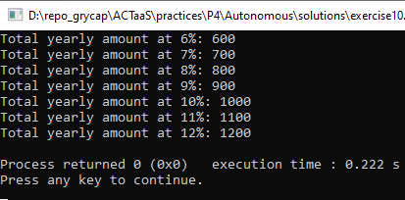

Exercise 11. Several experiments are performed, each consisting of six test results. The results for each experiment are stored in a file (experiment.txt), which has the following format:

Experiment1: 23.2 31.5 16.9 27.5 25.4 28.6

Experiment2: 22.2 28.7 12.8 27.5 43.4 19.6

….

Experimentn: 18.2 31.5 16.9 33.8 15.4 38.6

The value of n is unknown.

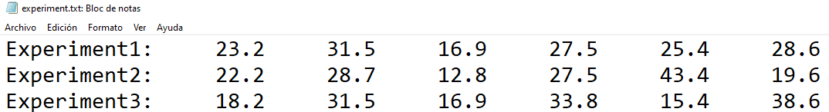

Design and implement a program in C that to compute and display the average of the test results for each experiment.

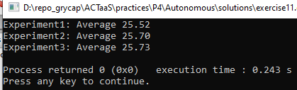

Exercise 12. A bowling team consists of five players. Each player bowls three games. Write a C program that displays the total score of each player and the average score, considering the five players. Consider the data are stored in a file (bowling_team.txt), which has the following format.

Bowler1: 286 252 265

Bowler2: 212 186 215

Bowler3: 252 232 216

Bowler4: 192 201 235

Bowler5: 186 236 272

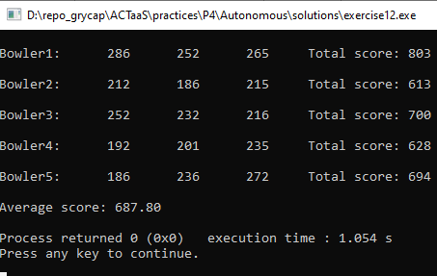

Exercise 13. Design and implement a program in C to display the following figure:

